Do a crossword puzzle.

|  |  |  |  |  |  |
| --- | --- | --- | --- | --- | --- |
| 1. |  |  |  |  |  |
| 2. |  |  |  |  |  |
| 3. |  |  |  |  |  |  |
|  | | | | | 4. |  |  |  |  |  |  |  | | | | |
| 5. |  |  |  |  |  |
| 6. |  |  |  |  |  |  |  |  |  | | |
| 7. |  |  |  |  |  |  |  |  |  |  |
|  | | | | | | | 8. |  |  |  |  |  |  |  |  |  |
| 9. |  |  |  |  |  |  |  |  |  |

1. 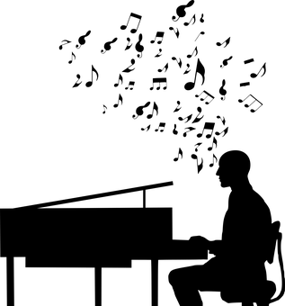 2. 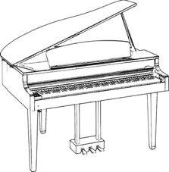 3. 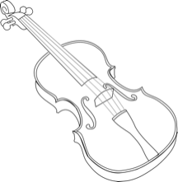 4. 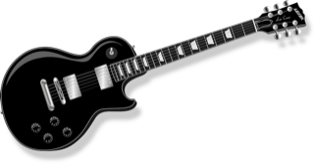  
5.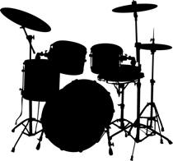 6. 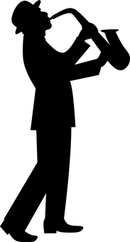7. 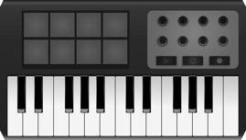 8. 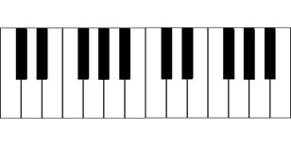 9. 