Do a crossword puzzle.

|  |  |  |  |  |  |
| --- | --- | --- | --- | --- | --- |
| 1. | M | U | S | I | C |
| 2. | P | I | A | N | O |
| 3. | V | I | O | L | I | N |
|  | | | | | 4. | G | U | I | T | A | R |  | | | | |
| 5. | D | R | U | M | S |
| 6. | M | U | S | I | C | I | A | N |  | | |
| 7. | S | Y | N | T | E | S | I | Z | E | R |
|  | | | | | | | 8. | K | E | Y | B | O | A | R | D |  |
| 9. | S | A | X | O | P | H | O | N | E |

1. 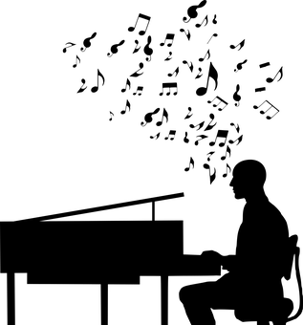 2. 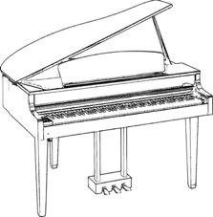3. 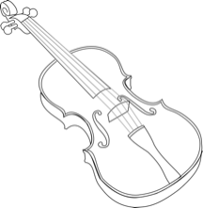 4. 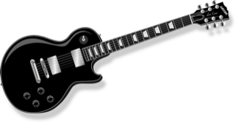  
5.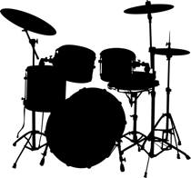 6. 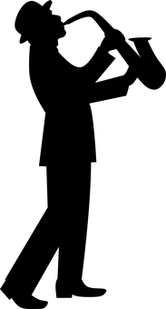7. 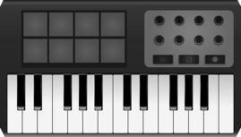 8. 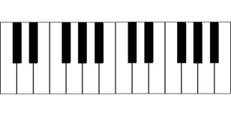 9. 